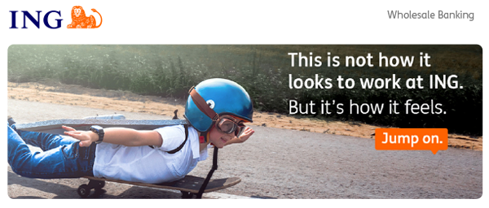
ING WB Asia Internship Programme 2025
“At ING, we’re redefining what it means to be a bank and we’re looking for people with the right skills to jump on. If you’re a smart, driven student with global ambitions who wants to make a real difference, our internship might be for you.”

Position: | Intern (Undergraduate)
Dept/Function: | Client Services Delivery (“CSD”)
Internship Period: | Full time for 6 months
Openings | 1 intern
Please note that the application deadline for this internship is 20th May 2025.

Why ING?
The world of banking is changing faster than ever. That’s why we at ING are always broadening our horizons. Our people have a forward-thinking mentality, a strong can-do spirit and enjoy working in an agile environment.

ING in Asia Pacific
In Asia Pacific, ING offers wholesale banking across 11 markets, namely Australia, China, Hong Kong SAR, India, Indonesia, Japan, the Philippines, Singapore, South Korea, Taiwan, and Vietnam.

ING offers both retail and wholesale banking services in Australia. ING’s regional presence includes a 13% stake in Bank of Beijing, China and a 30% stake in TMBThanachart Bank in Thailand.

Singapore is the regional headquarters for ING's Wholesale Banking (WB) business in Asia, which includes all WB business lines such as Financial Markets, Strategic Products, Sectors, Lending and Transaction Services and other support functions.
What does the CSD Team do in ING?
Client Services Delivery (CSD) performs operational activities which covers Export/Import related process, such as document handling, internal communication with relevant stakeholders, client contact related transactions and perform regulatory reporting.

What would you be doing?
- Day-to-day Processing, regarding trade finance products, especaiily Export transactions
- Handles Local Application/Local reporting /Client in Local language;
- Liaising and Handles with Front Office, Agent, Client and all other relevant parties to ensure the smooth processing of transactions;
- Preparation of reports;
- Ensure that the Bank’s and relevant regulatory procedures and controls are adhered to;
- Perform ad-hoc duties assigned from time to time;
- Understand roles, authorities, responsibilities and obligations of compliance and conduct their business accordingly;
- Understand which of those are compliance related.

What qualities and skills are we looking for?
We are looking for a passionate individual who meets the following criteria:
- University student;
- Advanced MS Office skills;
- Fluent in English and Korean, both verbally and written;
- Ability to communicate well and work with people in different department at all levels;
- Willingness to learn and participate in activities; and
- Open minded and eagerness to challenge.

What would you gain from this internship?
- Understanding of banking business;
- Practice of banking operations;
- Better communication with clients or colleagues;
- Priority set with multiful tasks;
- Improved skills with MS offices; and
- Achievement common objectives through Team work;

Required Documents
- English Resume;
- Academic Transcript (with Cumulative GPA);
Candidates who are interested in this job position should apply directly through ING Career Website: https://ing.wd3.myworkdayjobs.com/ICSGBLCOR/job/Seoul/XMLNAME--BANK--Client-Services-Delivery-2025-2H-Intern_REQ-10095706-1

Need more information?
Contact Eunyoung Yoo (Telephone no. 02-317-1595 / Fax 02-317-1598),
For information on ING Wholesale Bank, visit https://www.ingwb.com/
For information on careers, visit https://www.ing.jobs/Global/Careers.htm

