[2026 WORLD ISLAND EXHIBITION YEOSU KOREA –
International AI Video Art Contest] Announcement
Note: This document is an English translation of the original Korean version and has been reviewed. Minor translation errors or discrepancies may remain. For any questions or clarifications, please contact us at the email address provided in the contest announcement.

1. Contest Schedule
• Submission Period : June 5, 2026 - July 17, 2026, until 5:00 PM (KST)
• Announcement of Winners : July 24, 2026
• Exhibition Period : September 5, 2026 - November 4, 2026
• Awards : Open Division - 1 Grand Prize, 2 Excellence Awards, 4 Merit Awards /
Student Division - 1 Grand Prize, 2 Excellence Awards, 4 Merit Awards [Total of 14 Winners]

2. Contest Overview
• This contest is open to talented artists from Korea and abroad with artistic vision. Selected works will be officially submitted to and exhibited at 「2026 WORLD ISLAND EXHIBITION YEOSU KOREA」
• In addition to the winning works, this contest may offer exhibition opportunities to selected entries through an internal review process. Exhibited works will be displayed alongside video works by invited artists from Korea and abroad on the exterior wall of the Landmark of the 2026 World Island Exhibition Yeosu Korea.
• Host and Organizer : 2026 World Island Exhibition Yeosu Korea Organizing Committee

3. Contest Theme
• ‘Imagining the Islands of the Future with AI’
Using AI and IT technologies, participants are invited to create a video artwork that envisions a future version of islands as a microcosm of the Earth, incorporating ESG messages. This contest aims to reinterpret global challenges condensed within islands through AI-assisted video, promote exchange among global creators, and contribute to the advancement of AI-based video production skills and technological application.

4. Contest Divisions and Artwork Requirements
Notice : Participants may enter either as an individual or as a team of up to four members. Duplicate participation as both an individual and a team member is not permitted.

The contest divisions and artwork requirements are as follows.
• Open Division - At least 70% of the video artwork production process must involve the use of AI tools.
• Student Division - At least 60% of the video artwork production process must involve the use of AI tools.

*For team entries, one representative must be designated. Prize payment and all related administrative procedures will be handled through the designated representative.

5. Artwork Specifications and Exhibition Guidelines
<Video Specifications>
- Video Length : Approximately 2 minutes
- Resolution : 3264 × 1300 px (in total across two display surfaces)
- Frame Rate : 30 fps
- Format : H.264 mp4 or mov / Rec. 709
(Videos in Rec. 2020 or HDR may not be supported for screening.)
- Audio : Max peak -3dB

• Video artworks must be submitted in digital file format. When submitting the video, applicants must carefully check and comply with the required technical specifications, including the designated format and resolution.
• The organizer shall not be responsible for any technical issues that may occur during screening if the submitted artwork does not comply with the required specifications.

< Notes for Video Production>
• With a resolution of approximately FHD per side, there are limitations to the expression of detailed textures (such as smoke, fire, and water). To ensure visibility during actual broadcast, each visual effect appearing in the video must be rendered as large, distinct blocks.
• Resolution: 3264 × 1300 px for both sides
• From the viewer’s perspective, both sides will be visible at a glance. We recommend working at a resolution of 3264 × 1300 px based on the two sides. (*some details are subject to change)
• There may be a gap where the two sides meet. The gap between two side is approximately 25mm (*some details are subject to change)
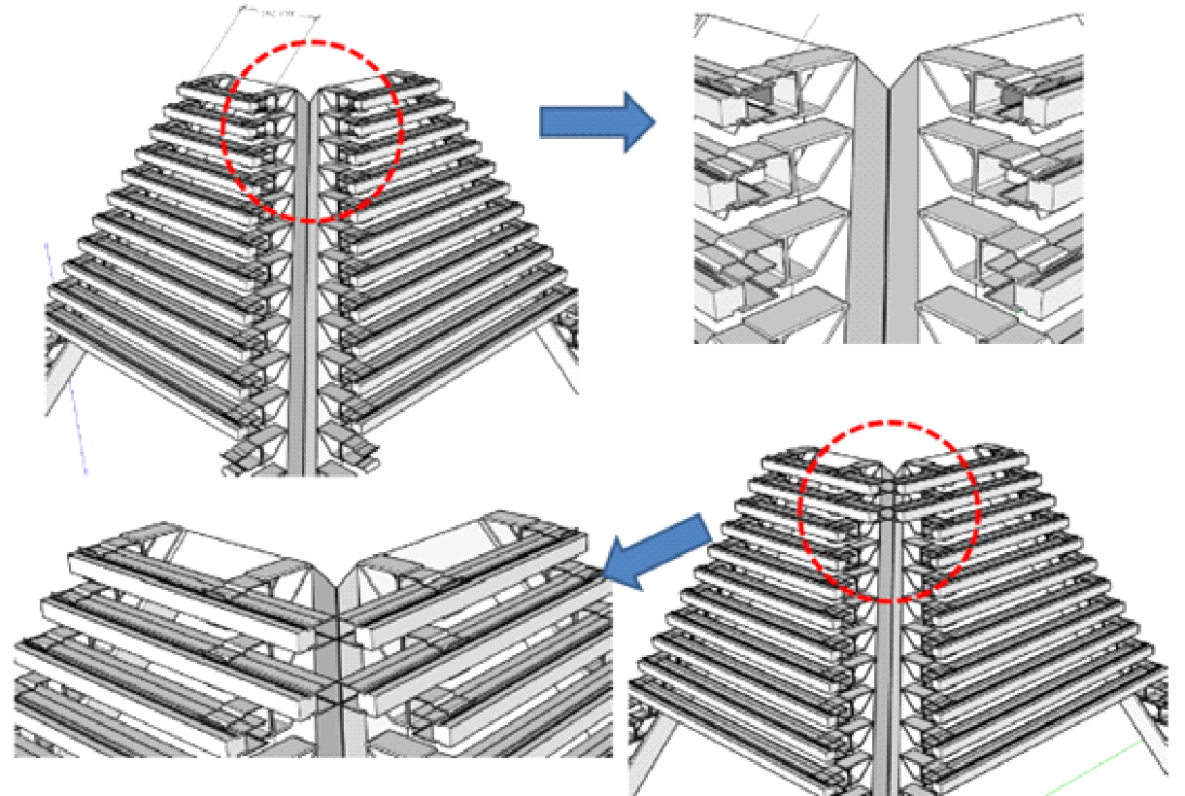
- Pipes are wrapped around the pyramid structure from the bottom up, and LED chips are installed on the pipes.

*Before producing the video, applicants are advised to refer to the attached document, [Production Brief for Landmark Media Artwork] to better understand the display facility.

6. Copyright and Consent for Use
• The copyright of each work submitted to this exhibition shall belong to the respective artist.
• The artist grants the host and organizer (hereinafter referred to as the “Organizing Parties”) a non-exclusive license to photograph, reproduce, distribute, exhibit, publicly transmit (including online posting), edit, and otherwise use all or part of the work, or photographs and videos containing the work, for the purposes of promoting, reporting, educating, researching, documenting, and establishing archives related to the exhibition. This license shall be granted without additional compensation and shall not be subject to any limitation on the period of use.
• When using the work in accordance with the preceding paragraph, the Organizing Parties shall not damage or distort the essential content or form of the work, nor use the work in a manner that may harm the artist’s reputation.
• The Organizing Parties shall credit the artist’s name within a reasonable scope.
• Any work that infringes upon the copyright, portrait rights, or other rights of third parties shall be excluded from judging and exhibition, and the participant shall bear all related legal responsibility.

※ Submitted works must be free from any legal issues related to copyright, portrait rights, or other third-party rights.
​※ Applicants must submit supporting materials, such as screenshots, verifying the prompts entered into generative AI tools. These materials must be attached to the application form.

7. Required Documents
• (Form1) Application Form for the 2026 World Island Exhibition Yeosu Korea AI Video Art Contest
• (Form2) Consent Form for the Collection, Use, and Provision of Personal Information and the Processing of Unique Identifying Information
• (Form3) Pledge Form for the 2026 World Island Exhibition Yeosu Korea AI Video Art Contest
• (Form4) Consent Form for the Use of Portrait Rights *To be completed and submitted only if applicable
• (Form5) Consent Form for the Use of Submitted Materials and Copyright
• (For Student Division applicants) Certificate of Enrollment or Certificate of Leave of Absence
• (To be submitted by prize winners) Original artwork file, identification document (such as resident registration card, driver’s license, youth ID card, passport, or other valid ID), proof of student status if applicable, and bank account information or a copy of bankbook for prize payment

8. Submission Method
• Applicants must organize the required documents and video artwork file into a single folder and submit them by email to the Contest Operation Office.
• Submission Email : yeosu2026aicontest@gmail.com
• The email subject line should follow the format below :
[International AI Video Art Contest] Applicant Name(or Team Name)_Division
• Submitted files should be organized using the applicant’s name or team name.
• If the video file is too large to attach to the email, applicants may include a downloadable link in the body of the email. The link must remain accessible for a certain period after the submission deadline.
• Submissions received after the deadline or submissions with missing required documents may be excluded from judging.

9. Judging Criteria
• Effectiveness in Communicating ESG Messages : 30%
• Use of AI Technology : 25%
• Overall Quality of the Video : 25%
• Originality : 20%

10. Awards and Prize Money
Open Division
• Grand Prize (1 winner) : KRW 7,000,000
• Excellence Awards (2 winners) : KRW 2,500,000 each
• Merit Award (4 winners) : KRW 500,000 each

Student Division
• Grand Prize (1 winner) : KRW 4,000,000
• Excellence Awards (2 winners) : KRW 2,000,000 each
• Merit Award (4 winners) : KRW 500,000 each

Total: 14 winners / Total prize money: KRW 24,000,000

※ The award details and the number of winners may be adjusted if no submitted works are deemed eligible or if the number of submissions falls short of expectations.

11. Other Notes
• Submitted works should be structured as narrative-based videos. Rather than relying on overly explanatory methods, the story should be conveyed naturally through imagery and visual flow. Even when using abstract expressions, the theme and meaning of the work should be sufficiently embedded within the video. Applicants should also consider harmony with music in order to enhance the immersive quality of the video. In line with the purpose of the AI Video Art Contest, applicants are encouraged to create works that make use of original techniques, visual expressions, and experimental direction that move beyond conventional video production methods.
• Submitted works must be new and unpublished. If plagiarism or unauthorized use is confirmed, the selection will be canceled, and the work will be withdrawn from the exhibition.
• All submitted materials will not be returned.
• Due to the characteristics of the exhibition space, the exhibition of certain works may be restricted. Applicants are therefore encouraged to produce their works in accordance with the specifications provided in ‘5. Artwork Specifications and Exhibition Guidelines.’ For works with specifications other than those stated, applicants are advised to contact the contest office in advance.
• The exhibition schedule and venue may be subject to change depending on circumstances. Any changes will be announced separately.
• For further inquiries, please contact the Contest Operation Office.

- Inquiry: yeosu2026aicontest@gmail.com

