[Production Brief for Landmark Media Artwork at the 2026 WORLD ISLAND EXHIBITION YEOSU KOREA]

Table of Contents
<Theme Island/Landmark: Lumi Isle> ---------------------------------- Page 2
<Media Facade - Video Display Facility> ---------------------------------- Page 3
<Understanding Islands> ---------------------------------------------------- Page 6
- Redefining Islands
- The Importance of Islands
- The Value of Islands
- Formation of Islands (Page 8)
- Causes of Island Disappearance (Page 9)
- Methods and Processes for Island Revitalization (Page 12)

Note: This document was translated from Korean into English with the assistance of DeepL AI and has been reviewed. Some translation errors may remain.
<Theme Island/Landmark: Lumi Isle>
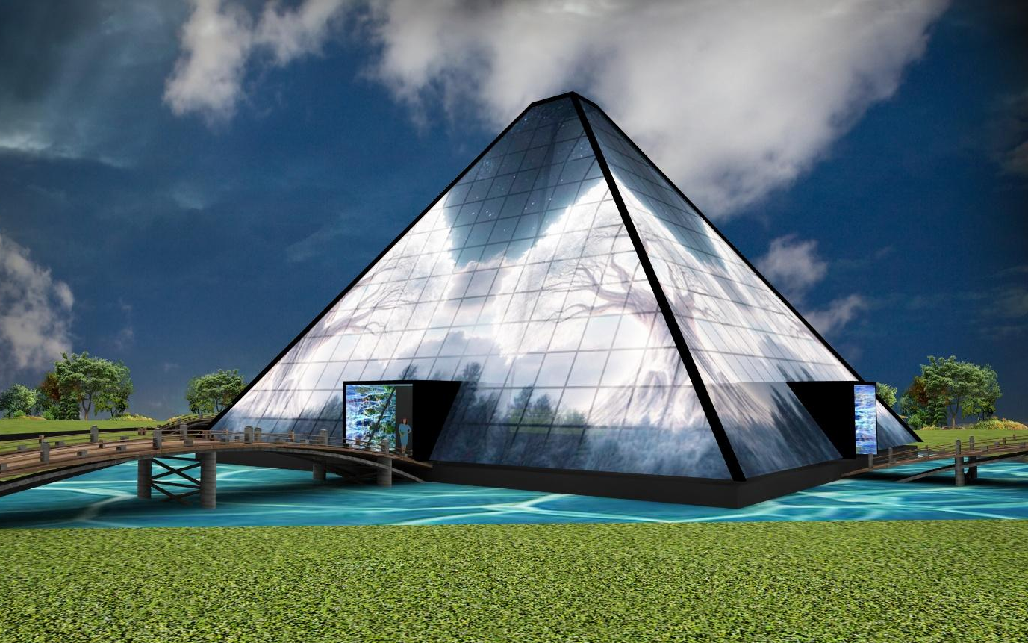
Lumi Isle, the Island of Light: A portmanteau of “light/media” and “island”, it signifies an island of light and an island of the digital future.
• Form: Pyramid (permanence, mystery, apex, monumental)
• Meaning: Island = Future asset, nature, isolation and connection, sustainability
• Function: Media sculpture (light, video, information, emotion)
• Purpose: Landmark (a central feature that is memorable and attracts visitors)
Located at the heart of the World Island Exhibition Yeosu Korea, Lumi Isle—symbolizing the “Island of Light in the Future”—is a digital landmark embodying the assets of a sustainable future.

<Media Facade - Video Display Facility>
Notes for Video Production:
- With a resolution of approximately FHD per side, there are limitations to the expression of detailed textures (such as smoke, fire, and water). To ensure visibility during actual broadcast, each visual effect appearing in the video must be rendered as large, distinct blocks.
- From the viewer’s perspective, both sides will be visible at a glance.
- We recommend working at a resolution of 3264 × 1300 px based on the two sides. (*some details are subject to change)
- There may be a gap where the two sides meet. The gap between two side is approximately 25mm (*some details are subject to change)
Resolution: 3264 × 1300 px for both sides

Please review the attached photos on the following page.

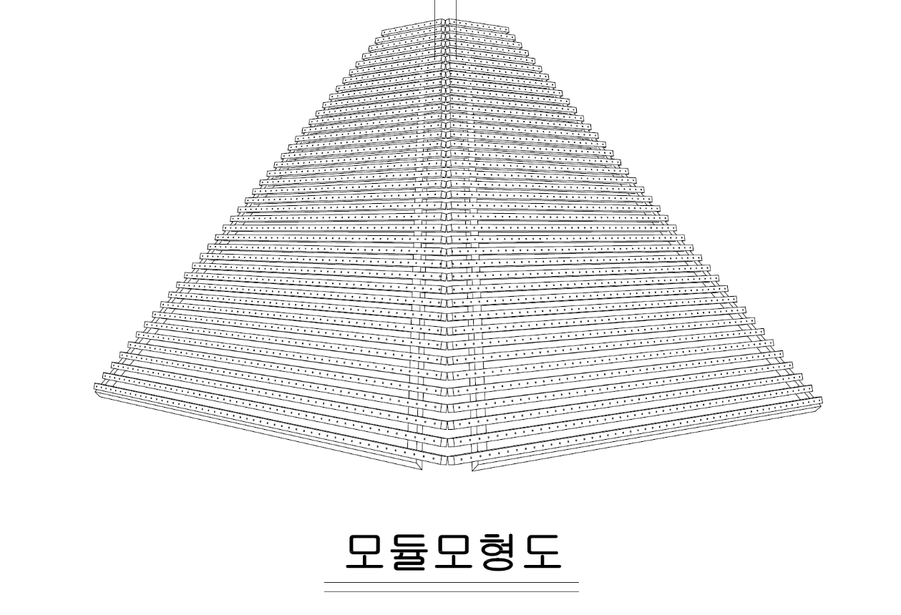
▲ This is the expected view when looking from the center of the two sides. The gap between the sides is approximately 25 mm
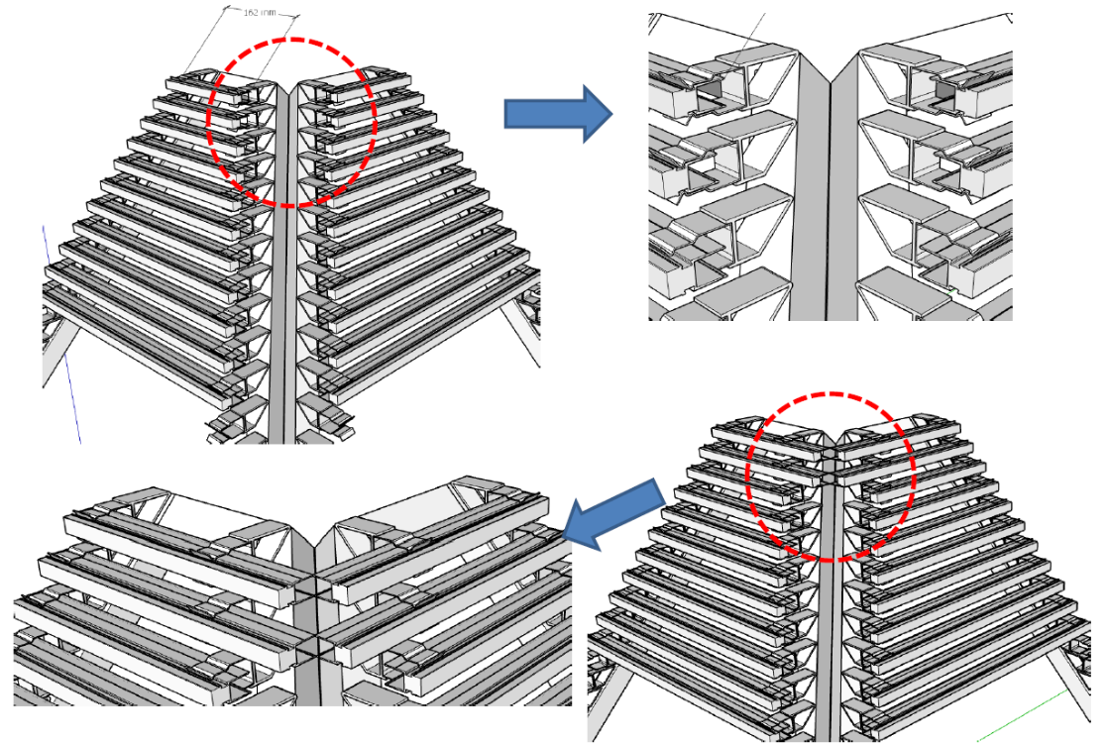
▲ Pipes are wrapped around the pyramid structure from the bottom up, and LED chips are installed on the pipes.

▲ Expected image of LED pixels

<Understanding Islands>
- Redefining Islands
• An island is not merely isolated land, a marginalized space, or the edge of the mainland, but a strategic asset for the future
• Islands possess immense potential in various areas such as the economy, energy, and the environment

- Why Islands Are Important
• Core values of islands: resources, energy, technology, environment, and people
• As future maritime platforms, islands are spaces where energy can be produced, cutting-edge technologies tested, and a new form of capital—carbon credits—generated. Islands also serve as strategic maritime bases for humanity’s sustainable survival

- The Value of Islands
3-1. Marine (Economic) Territory Bank: The Expansion of Invisible National Wealth
• The Exclusive Economic Zone (EEZ), established within a 200-nautical-mile (approx. 370 km) radius from an island, provides maritime territory dozens of times larger than the land area
• Islands serve as “maritime logistics terminals” for extracting and transporting these resources

3-2. 'Giant Battery': A Hub for Energy Self-Sufficiency and Export
• Islands have a much higher density of natural energy sources (wind, sunlight, waves) than the mainland
• A massive source of eco-friendly fuel: Green hydrogen production facilities that use wind and solar power generated on the island to electrolyze seawater and produce hydrogen
• Energy Storage Systems (ESS) – As islands are isolated from mainland power grids, they are the ideal testing ground for energy storage and efficient distribution technologies
• Deep-sea mineral resources: Deposits of cobalt, manganese, rare earth elements, and other key raw materials for next-generation batteries

3-3. 'Regulatory Sandbox': A Giant Laboratory for Advanced Technologies
• Islands are the ideal place to safely test new technologies in a controlled environment before they are applied to society
• Unmanned mobility solutions, such as drone taxis (UAM) and autonomous ships, are used as a means of transportation between islands or between islands and the mainland, rather than in complex urban centers
• Eco-friendly data centers: Cooling systems that utilize the cold seawater surrounding islands drastically reduce operating costs (Microsoft’s ‘Project Natick’ is a prime example)

3-4. ‘Blue Carbon’ Exchange: A Gold Mine in the Carbon-Neutral Era
• Tidal flats and seaweed forests (such as Zostera) surrounding islands absorb carbon up to 50 times faster than mainland rainforests
• Simply by preserving the island’s ecosystem, it is possible to generate substantial added value by selling carbon credits
3-5. 'Premium Wellness': A New Paradigm for Housing and Leisure
• A futuristic space that caters to the needs of digital nomads and high-value-added tourism
• Workation Hub – With just a high-speed internet connection, an island can become a “dream office” that attracts talent from around the world
• “Smart Food Island”: Combining smart aquaculture systems with the island to stably produce high-value seafood

- Island Formation
4-1. Volcanic Activity (Volcanic Islands) - When a volcano erupts on the ocean floor, lava accumulates until it eventually rises above sea level
Notable Examples: Hawaiian Islands, Ulleungdo, Dokdo, Jeju Island

4-2. Continental Drift and Separation (Continental Islands) – Islands that were originally part of a massive continent but became isolated due to tectonic shifts causing landmasses to break away or sea levels to rise
Examples: Greenland, Madagascar, the United Kingdom, the Japanese Archipelago

4-3. Coral Deposition (Coral Islands) - Islands formed in the shallow waters of tropical regions where coral reefs grow and their remains accumulate over a long period of time
Examples: Maldives, Marshall Islands

4-4. Glacial Retreat (Glacial Islands) - Islands formed when massive glaciers pressed down on and moved across the Earth’s surface during the Ice Age, and after the Ice Age ended, water filled the carved-out terrain left by melting glaciers
Examples: Islands in northern Canada, small islands around the Scandinavian Peninsula

4-5. Crustal Equilibrium Movement (Uplifted Islands) - Cases where tectonic plates push against each other, or where the crust, previously compressed by heavy ice (glaciers), gradually rises due to rebound, forming islands
Representative examples: Some islands along the Baltic Sea coast (which are still rising by a few millimeters per year, increasing in area)

4-6. Artificial Islands (Man-made Islands) – Although not a natural phenomenon, these are islands created in modern times by reclaiming land from the sea for economic or military purposes
Notable examples: Palm Jumeirah in Dubai, Incheon International Airport (reclaimed land on Yeongjong Island), Kansai International Airport in Japan

- Causes of Island Disappearance
5-1. 'Erosion' caused by waves and wind
• Wave action – Waves erode the island’s coastline, and wind weather the rocks. In particular, islands formed by volcanic activity often have weak foundations, leading to very rapid erosion. The island’s area gradually shrinks until it eventually sinks below sea level

5-2. Sea Level Rise
• The most prominent cause of extinction due to recent global warming
• A phenomenon in which islands gradually submerge as the volume of seawater increases due to melting glaciers
• It is not merely a matter of the land being submerged; seawater infiltrates the groundwater, making farming impossible and rendering the island uninhabitable

5-3. Salinization of Groundwater: ‘Social Extinction’
• A situation where “habitability” disappears before the land physically vanishes
• As sea levels rise, saltwater mixes with the precious freshwater (groundwater) aquifers beneath the island. When the water becomes undrinkable and farming is no longer possible, the land—though still physically present—can no longer function as an island and becomes abandoned

5-4. Crustal Subsidence and the Formation of Guyots
• The island itself sinks downward due to movements within the Earth
• Over time, the weight of massive lava-based volcanic islands causes the crust to be pushed downward (crustal equilibrium), or the island moves toward the deep sea and sinks due to plate tectonics.
• ‘Guyot’ – The upper part of the island is eroded by waves until it becomes flat, eventually leaving behind a flat-topped mountain in the deep ocean.

5-5. Explosive Volcanic Collapse
• Paradoxically, islands formed by volcanoes can also be destroyed by them—if a volcano erupts with such force that the island’s core is hollowed out, it collapses in on itself (forming a caldera)
• Alternatively, one side of the volcano may collapse into the sea like a massive landslide
For example, in 1883, two-thirds of Indonesia’s Krakatoa Island vanished in an instant following a massive eruption

5-6. Intensified Typhoons and Storms: “Disappearance Overnight”
• Typhoons intensified by global warming unleash massive waves that wash over islands, sweeping away the sand and soil that make up the island all at once; small, vegetation-free sandbars are particularly vulnerable, and even a single powerful typhoon can cause a small island to vanish.
For example, East Island near Hawaii completely disappeared from maps after Hurricane “Waraku” passed through in 2018

5-7. Coastal Erosion: “Land Eroded by Waves”
• Occurs when wave currents around an island change or due to human development
• Sand along the coastline is carried away by waves to other locations; if it is not replenished, the land continues to shrink. Building breakwaters near the island or extracting sand can distort the direction of the waves, causing the coastline on the opposite side to erode rapidly

5-8. Artificial Causes: “Disappearance Due to Economics and Politics”
• Cases where islands disappear due to human decisions rather than natural phenomena
• Small islands or reefs may be quarried for materials to build larger ports or expand other islands; in some cases, the original terrain is completely destroyed during the construction of military bases or bombing ranges, causing the island’s identity to vanish

- Methods and Processes for Island Revitalization
Based on five values: physically preserving them (environment), enabling them to shine on their own (energy, resources), and connecting people through technology (technology, people)

6-1. Environmental Survival: Protecting the Coastline and Restoring “Blue Carbon”
• Building “green infrastructure” that absorbs wave energy and restores ecosystems by utilizing artificial coral reefs, oysters, and shell fragments instead of concrete structures
• Need for 'blue carbon forests' by planting seagrass, mangroves (tropical), and halophytes to prevent coastal erosion and increase carbon sinks

6-2. Energy Self-Sufficiency: The ‘Carbon-Free Island (CFI)’ Project
• A method to reduce dependence on external energy sources, thereby lowering island operating costs and increasing value
• Generate renewable energy—such as solar, wind, and tidal power—suited to the island’s natural environment, and connect it to ESS (energy storage systems) to create an energy self-sufficiency system.
• Replace all transportation on the island with electric vehicles or electric vessels to strengthen the ‘Clean Island’ brand image

6-3. Economic Self-Sustainability: Industrialization of 'Smart Food & Tourism'
• Create high-value-added revenue streams to prevent island residents from leaving
• Cultivate high-value fish species at smart aquaculture farms incorporating ICT technology, and brand them as island specialties
• Establish ultra-high-speed satellite internet (e.g., Starlink) infrastructure to create a “workation” environment where global talent can work and live on the island (attracting digital nomads)

6-4. Technological Response: ICT-Based “Smart Island”
• Dramatically improve living conditions by using drone delivery to address gaps in the delivery of daily necessities and medical supplies
• Address the physical limitations of island life through digital technologies (telemedicine and remote education)

6-5. Legal and Institutional Strengthening: Redefining the “Value of Islands”
• Institutional support is needed to clearly establish that maintaining islands is in the national interest
• Strengthen management of uninhabited islands—recognize their value as baselines for territorial waters and modernize management facilities (lighthouses, observation stations, etc.)
• Stimulate investment through dedicated legislation that simultaneously supports island resource development and environmental conservation

